A Report to Offer Technical Solutions to Increase Server-Side Data Security in Cloud-Based File Transfer Systems in Bilkent University Electric-Electronics Department Labs

1 Introduction

Data Breach, Online Security, Pilot study area: EE labs.

Purpose: Present solutions toincrease security in cloud servers

Impact: positive short-term impact to security to EE labs.

Significance: Global applicability.

2 Problem Definition

1. Client-side error

Clients are responsible for 52% of the breaches.

1. Recent changes in cloud companies’ data policies to exculpate personal data analysis

Personalized ads, intent analysis, public profiling are bad for the privacy and data security.

1. Server-side vulnerability of storage based file-transfer systems

3 Proposed Solutions

1. Personal Cloud Server Setup

* Person owns the server.

1. Server-side Ephemeral (Cache-only) Storage

* Deletes the files after a while.

1. Peer-to-Peer File Transfer Protocol (Server Bypass)

* No storage server.

4 Criteria for Assessing Proposed Solutions

1. Feasibility

* Practicality
* Acceptability
* Applicability

1. Integrability

* Required software dependencies
* Operating system
* Average Bandwidth usage

1. Extensibility

* How well can the solution be adapted if there is user increase.

5 Proposed Research Methodology

1. Literature Review

* Looking for previous research.

1. Market Research

* Researching cost.

1. Data Analysis

6 Results and Analysis

1 to 9 scale, 5 is the base case.

Base case: Average of Google, Apple and Amazon

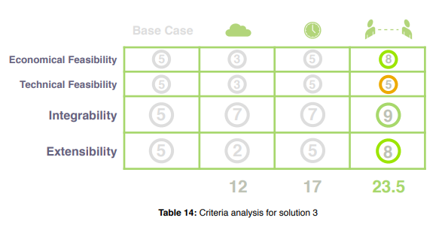

Economic Feasibilty - Cost of implementing the solutions.

Technical Feasibility – implementaton and “easy to use”

These are from Results and analysis part

Questions:

1. Why is the base case cloud file transfer systems and if the pilot study area is EE labs? What happenend in the EE labs?
2. How can Peer-to-Peer file transfer method can be a substitute for cloud-based well known services, since Peer-to-Peer transfer method is not cloud based?
3. If the problem is security of cloud based file transfer systems, Why does none of the criteria include security?
4. If the base case includes the “plug and play” and ease of use but criteas are not include “ease of use” (in part 4. But in part 6 it appears)
5. Cache-only solution solves which part of the problem? (user error is still present)